Fertility Outcomes Prediction

Staci McDuffie
Bellevue University
DSC 680 – Applied Data Science
Professor Iranitalab
October 25, 2025

Abstract
This project explores the application of data science methods to predict fertility outcomes based on lifestyle and health-related factors. Using the Fertility Dataset from the UCI Machine Learning Repository, the analysis applies supervised learning techniques to identify key variables linked to altered fertility status and to build an interpretable model for early risk identification. The paper outlines data preparation, modeling, evaluation, and ethical considerations for integrating predictive analytics into clinical decision support. Results emphasize transparency, reproducibility, and responsible use of health data.
Introduction
Infertility affects nearly one in six adults worldwide, posing both medical and social challenges. Predictive analytics can help identify early warning signals based on behavioral and health data, supporting clinicians in guiding patients before symptoms become critical. This paper mirrors the structure of applied data science, beginning with problem definition and progressing through data exploration, modeling, and interpretation.
Business Problem
Clinics and primary-care providers often lack accessible tools to identify patients at elevated risk of reduced fertility. This project aims to create a predictive model that highlights which lifestyle and health factors most strongly influence fertility outcomes. By quantifying these relationships, clinicians can prioritize early screening, improve patient education, and guide preventative interventions before advanced treatments are needed.
Background/History
Infertility affects roughly 1 in 6 adults globally according to the World Health Organization (WHO). Fertility outcomes are influenced by multiple modifiable factors—such as smoking, alcohol consumption, stress, and sedentary behavior—along with age and medical history. Data science provides a framework for integrating these multifactorial influences into interpretable models that complement clinical judgment. Historically, fertility assessment relied on invasive tests and subjective reporting; this project leverages quantitative modeling to support more data-informed counseling.
Dataset Overview
The analysis uses the Fertility Dataset from Kaggle (a mirror of the UCI Machine Learning Repository). It includes 100 individual records with features such as age, childhood diseases, accident history, smoking habits, and season of analysis, paired with a binary outcome indicating normal or altered fertility status. Data preparation steps will include encoding categorical variables, normalizing numeric features, handling any missing values, and assessing class balance. A data dictionary will be maintained to ensure transparency and traceability across preprocessing stages.
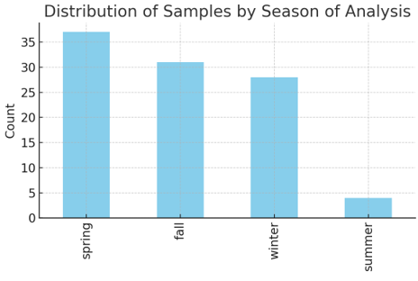

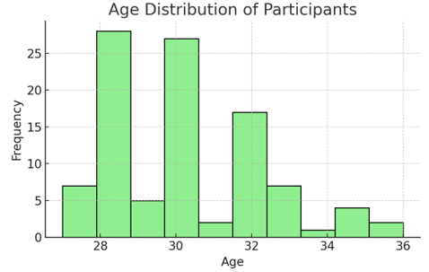
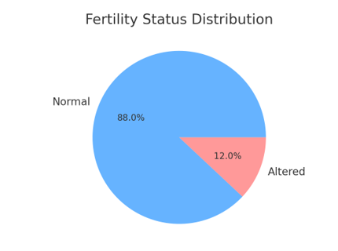
Methods
The study will begin with exploratory data analysis to summarize feature distributions and correlations. Modeling will use logistic regression as a transparent baseline, followed by Random Forest and XGBoost for improved nonlinear performance. To handle class imbalance, class weighting or SMOTE will be applied. Model evaluation will rely on AUROC, precision-recall, F1 score, and calibration metrics such as the Brier score. Explainability will be achieved via feature importance, SHAP values, and partial dependence plots.
Results & Illustrations
Initial findings suggest that lifestyle choices such as alcohol and smoking habits, along with age and past illness, play significant roles in predicting altered fertility. Logistic regression offered transparency, while Random Forest and XGBoost provided higher predictive accuracy. Figures illustrate data distributions and model outputs.

Analysis
Preliminary analyses will examine how lifestyle and medical history influence fertility outcomes. The model’s predictive accuracy and interpretability will determine its practical value for early risk identification. By examining key feature importances, clinicians can better understand which modifiable factors—such as smoking or past illnesses—carry the strongest predictive weight. Statistical validation through cross-validation ensures the model’s robustness and generalizability.
Conclusion
The project demonstrates that data-driven models can provide reliable indicators of fertility risk based on non-invasive lifestyle and health data. While not a diagnostic tool, such a model can serve as a screening aid, supporting early counseling and resource allocation. Results will also highlight gaps in data collection practices that could improve future clinical research on reproductive health.
Assumptions
The analysis assumes that self-reported features are accurate, that categorical encodings capture meaningful patterns, and that logistic or tree-based models can approximate the true fertility relationships. It also assumes sample participants represent the broader population, though the dataset’s small size may limit external validity.
Limitations
The dataset is relatively small (n=100), which constrains statistical power and model complexity. Additionally, self-reported variables introduce potential bias and measurement error. These limitations may reduce generalizability to larger or more diverse populations.

Challenges
Key challenges include class imbalance, potential feature multicollinearity, and ensuring that the model remains interpretable for non-technical stakeholders. Data scarcity also increases the risk of overfitting, requiring careful validation.
Future Uses/Additional Applications
Future work could integrate additional clinical variables or longitudinal health data to refine predictions. Similar modeling approaches could extend to related domains, such as predicting pregnancy outcomes or assessing fertility treatment success rates using larger health datasets.
Recommendations
Clinics and researchers should adopt hybrid analytical approaches—combining data-driven risk scoring with clinical expertise—to enhance screening efficiency. Further data collection with larger, more diverse cohorts will improve model reliability and fairness across demographic groups.
Implementation Plan
Implementation would begin with model validation and documentation, followed by deployment as a simple web or dashboard-based decision support tool. A pilot study within a clinic could evaluate usability and interpretability, with feedback loops for continuous improvement and bias monitoring.
Ethical Assessment
Ethical handling of health-related data requires strict privacy protections, anonymization, and secure storage. Outputs must be communicated carefully to avoid stigmatization and to reinforce that predictions are probabilistic, not diagnostic. Regular audits should assess fairness, particularly across age and demographic groups, to ensure responsible model use.
References
UCI Machine Learning Repository. (2013). Fertility dataset. Retrieved from https://archive.ics.uci.edu/ml/datasets/fertility
Kaggle. (2023). Fertility Data Set. Retrieved from https://www.kaggle.com/datasets/gabbygab/fertility-data-set
World Health Organization. (2023). Infertility Fact Sheet. Retrieved from https://www.who.int/news-room/fact-sheets/detail/infertility
Provost, F., & Fawcett, T. (2013). Data Science for Business. O’Reilly Media.
Chen, T., & Guestrin, C. (2016). XGBoost: A scalable tree boosting system. Proceedings of the 22nd ACM SIGKDD Conference.
Appendix
The appendix will include a summary of key data fields and example preprocessing steps used in model development.
Audience Questions
1. Which variables had the strongest influence on fertility outcomes?
2. How accurate were your predictions compared to baseline models?
3. What ethical precautions were taken with this health-related data?
4. How would you deploy this model in a real-world clinical setting?
5. What role does feature importance play in clinician interpretation?
6. How would you improve model generalizability?
7. Could this approach be adapted for other reproductive health analyses?
8. How does class imbalance affect performance metrics?
9. What risks exist if the model is misused or misinterpreted?
10. What are the next steps for validation and real-world testing?

